Denim and Diamonds - House of Friendship
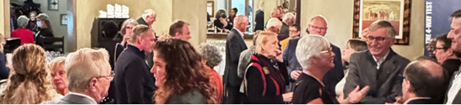
The House of Friendship is where you will connect with like-minded Rotarians and friends. Here, you can learn and be inspired through fun, conversation and interaction.
Clubs are encouraged to book a table, It’s free! Showcase your PROJECT, RAG, favourite FELLOWSHIP or the beneficiaries of your project, You can fundraise for the project you showcase: A raffle or sell cookies, preserves, books, cards, seeds etc.

BOOK your table now - IT IS FREE and as EASY as one short hassle-free email! Deadline: MARCH 15, 2025. There are limited booths available for fundraising.

The House of Friendship (HoF), will be open on:
- Friday, April 25, 2025, from 4:00 to 6:00 pm
- Saturday, April 26, 2025, from 9:00 am to 5:00 pm

Send your email or questions to elsabe@falkson.ca Make sure to include:
- The subject line of the email: HoF Booth Registration.
- What? The theme of your booth or project you want to promote or share.
- Who? Two names with contact details of volunteers - setting up and staffing. See GOOD TO KNOW – Booth staff.
- How? Will you be fundraising? Describe the proposed fundraiser
- When? You plan to set up (see GOOD TO KNOW)
- More? Special requirements like a power outlet, banners, etc.

GOOD TO KNOW:
- Set up is Friday afternoon 2-4 PM or Saturday morning 7:30 - 8:30 AM
- We do not have wall space for posters so bring your stand or easels.
- Booth space is approximately 10’ X 4’, with a table included.
- Take-down is Saturday 5-6 PM. There is no House of Friendship on Sunday.
- Booth staff are expected to be conference attendees. Each club can register up to two staff who are not conference attendees for a cost of $30 each. Note: excludes meals and plenary access. Make a note “BOOTH STAFF”, with names in comments. https://rotary7040.com/donate/conference-25
- Questions? Contact Elsabé Falkson elsabe@falkson.ca

