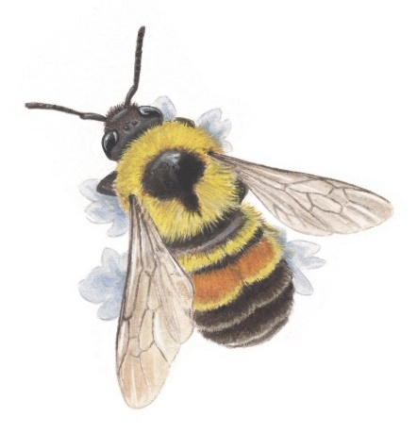
D7040 Biodiversity update: Habitat for pollinators
The BEE FRIENDLY - NO MOW MAY
FAQ, Concerns and Resources
“What about ticks?”
Usually, tick bites are often harmless and don’t cause noticeable symptoms. However, some ticks can transmit serious diseases, such as Lyme disease or Rocky Mountain spotted fever, to humans. The presence of ticks depends on factors like the weather (they prefer warmer humid climates), and time of the year (they are more active from April to September, but they can be around just about any time).
"Research indicates that taller grasses did not result in more ticks but did support higher abundances and diversity of native bees Promoting shorter grasses and the removal of grass clippings could have minimal impacts on tick microhabitats but would be consequential for beneficial wildlife such as pollinators, and other ecosystem services associated with urban biodiversity.”
Mowing your lawn won’t eliminate the tick problem. So, you must take other precautions:
- Areas, where children play should, be dry, preferably with good sunshine (to kill off ticks).
- Dress appropriately and inspect for ticks and remove them properly immediately.
- Repellents: there are a variety of all-natural clothing and lawn options
- Welcome (or at least tolerate) critters like opossums, squirrels and chipmunks, garter snakes, spiders, rats, mice, and wasps. They all eat ticks. Turkeys and chickens happen to eat them too!
Unfortunately, lack of biodiversity creates shortages of ticks’ natural enemies - animals like opossums (Virginia opossums) are tick vacuum cleaners! A small group of opossums can eat 10,000 to 12,000 ticks in a single month.
“Will it damage my lawn?”
Many people have been participating for several years with no discernible damage to their lawns. In June when you mow for the first time, leave at least one-third of the length. Grass should not be cut more than a third of its length as cutting any lower could kill your grass. Also, mowing less frequently and not so short later in summer will further help pollinators and conserve water in the drier months If some areas look a little yellow, especially with the change in weather, it may be better to plant some native perennial plants instead!
Lawns that are mowed more frequently are linked to fewer invertebrates and lower plant diversity, but more pests and invasive species. A metadata analysis study across North America and Europe found strong evidence that increased mowing intensity of urban lawns— has negative ecological effects, particularly on invertebrate and plant diversity. Pest species, on the other hand, benefit from intense lawn management. A longer, healthier lawn is more resistant to pests, weeds, and drought events. Even a modest reduction in lawn mowing frequency can bring a host of environmental benefits: increased pollinators, increased plant diversity, and reduced greenhouse gas emissions. Regular lawn mowing favors grasses, which grow from the base of the plant, and low-growing species like dandelion and clover. This is an issue because other species that have their growing tips or flowering stems regularly removed by mowing cannot compete. Allowing longer lawns, thereby facilitating urban lawn plant diversity has the effect of increasing the diversity of other organisms such as pollinators and herbivores. Source: Christopher J. Watson et al. “Ecological and economic benefits of low‐intensity urban lawn management” 19 December 2019, Journal of Applied Ecology.
Dr. Carly Ziter (Concordia University, Montreal) studies the carbon-capturing ability of lawns, and she found the typical American lawn is effective at capturing carbon. As it should be, all plants capture CO2 and send carbon to their roots. However, in lawns, the effectiveness of carbon capturing could be offset by the emissions required to maintain it. It is questionable if the aesthetic is worth the environmental cost. Instead of mowed turf, Americans can transform their lawns into frontiers of biodiversity and sustainability. Dr. Ziter says: “You don’t need to have a perfect lawn for it to be beneficial. You don’t have to have an incredibly intensive management system. It’s O.K. to have things to be a little wild.”
“I’m not sure, I hear turfgrass experts say one must mow...?”
“I saw a video and “lawn experts” say NO MOW MAY does not work in Canada!” The answer above to “Will it damage my lawn?” debunks that concern. Someone anonymously (no credits shown) has the interest and money to put out a sponsored video slamming “No Mow May”. There is certainly vested interest in the turfgrass industry: total revenues in the USA are an estimated $7.82 billion.
The University of Guelph’s Turfgrass Institute has been very vocal against “Bee Friendly-No Mow May” Bee-friendly - no mow May. Notably, the institute is generously supported by the turfgrass industry, the university, and the Ontario Ministry of Agriculture and Food. The Ontario Turfgrass Research Foundation (OTRF) directs and promotes turfgrass research for the benefit of the turfgrass industry and the general public. They are sponsored by Aqua-ad (massive water sprinklers, chemical products, and mowing equipment) and Zander Sod (turfgrass sod, seed, and fertilizer for residential and commercial customers, ENVU (golf courses, lawn care, herbicides vegetation and pest “management”), Green HorizonsSod Turfgrass farms, and Turfcare (equipment, irrigation. design).
What can I plant instead of (or in addition to) turfgrass?
Keep diversity in mind and plant several native species! Suggestions for planting groundcovers replacing turfgrass that tolerate light to medium foot traffic are Wild strawberry (Fragaria Virginiana), Blue violet (Viola sororia), Barren strawberry (Waldesteinia fragarioides), Partridgeberry (Mitchella repens), Field pussytoes (Antenaria neglecta), and Yellow Wood sorrel (Oxcalis grandis).
Cornell University offers useful instructions for homeowners to transform their lawns. The general idea is to limit the amount of grass and the associated maintenance. Replace grass with native plant alternatives, and introduce more landscape materials like rocks and mulch. Plant groundcovers, such as mosses, ferns, wildflowers, shrubs, and trees that have high carbon-capturing abilities. Leave the lawn to its own devices: less mowing and less irrigation. Natural species improve the health of an environment by increasing biodiversity.
What bees are we helping?
We hope to protect as many pollinators as possible. There are approximately 400 native bee species found in Ontario that pollinate. There are also non-bee pollinators such as flies, butterflies, wasps, beetles, bats, and hummingbirds. They have a huge impact on our ecosystems. The non-native honey bee can’t pollinate all crops, and some plants, such as squash, rely heavily on pollination by wild bees.
Most native pollinator bees only have a window of days or weeks where the females are active, and all their reproductive output happens within that time. They can also be very plant-specific food-wise, unlike the honey bee which is a generalist. This becomes a major problem for wild pollinators who are dealing with habitat loss, pesticides, and disease.
Our native Bumble bees are excellent pollinators. They are generalist foragers so do not depend on any one type of flower. They are often the first bees active in early spring and the last in fall. Since they are active for so many months, they need to forage on a wide variety of early and late-season food resources (blooming flowers) plant species
What is our impact and should we support growing Bee Friendly No Mow May?
I am sure participants will be rewarded with many happy sightings of pollinators like Megan Day from the Kanien'kehá:ka community of Kahnawake. Take a picture and share what you find in your garden! Please contribute to iNaturalist and Bumblebee watch.
A non–Rotarian thanked me for this initiative. She told me she has not been mowing for several years, and she said: With Rotary endorsing this people will start to take it seriously!
In District 7040 there is the potential for at least 1.25 million hectares of pesticide-free, native bee habitat if homeowners participate in “Bee Friendly-No Mow May” and continue to create urban micro-ecosystems with pollinator habitats and major sources of nectar. This year we will follow through with “Leave the Leaves” in the fall. Next year we will do even more with an important message: We can all help create biodiversity and habitat.
Imagine the impact!
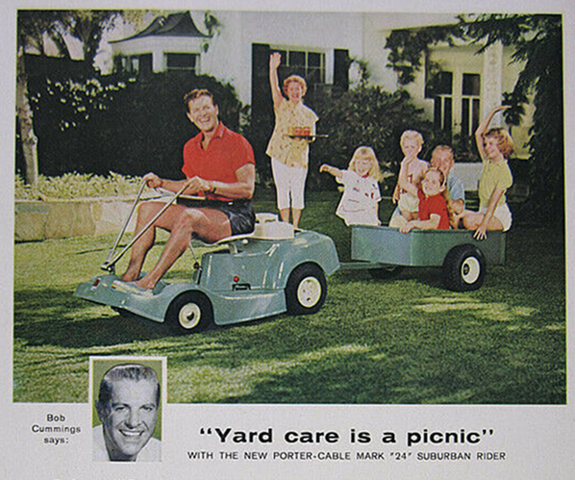
Times have changed! A happy family and responsible prosperous neighbour have an immaculate weed-free green lawn, sharply trimmed edges, orderly flower beds, and a few accent plants. Anything else does not fit and is often downright eye-rolling offensive. Today many subdivisions have very particular community bylaws prescribing uniformity. Homeowners have been exposed to this “IMAGE” through advertising, media, gardening books, and peer pressure for a century. We need to question what we took for granted in order to sustain our environment.

References and resources:
Why Lawns Suck (And A Few Alternatives That Don't)
https://psci.princeton.edu/tips/2020/5/11/law-maintenance-and-climate-chang
https://journals.plos.org/plosone/article?id=10.1371/journal.pone.021461
https://www.carlyziter.com/research.html
Convert Your Lawn by Sheet Mulching
https://youtu.be/ozQSNdPzD48
https://www.cbc.ca/natureofthings/features/opossums-misunderstood-marsupials
https://scitechdaily.com/mowing-lawns-less-increases-biodiversity-reduces-pests-and-saves-money/
https://www.inournature.ca/native-groundcovers.
Lawn Care: The Easiest Steps to an Attractive Environmental Asset.
https://www.cbc.ca/news/canada/montreal/no-mow-may-kahnawake
https://www.bumblebeewatch.org

